Worksheet 9 STAT301 Name Charles Sandahl
- Use the USairpollution data on D2L and do a correlation matrix plot to see the correlations between temperature, wind, and precipitation. Based on the correlation matrix plot, what are the correlations between chest circumference and waist, between chest and hip circumference, and between waist and hip circumference? Use column=c() to include the titles of the columns.
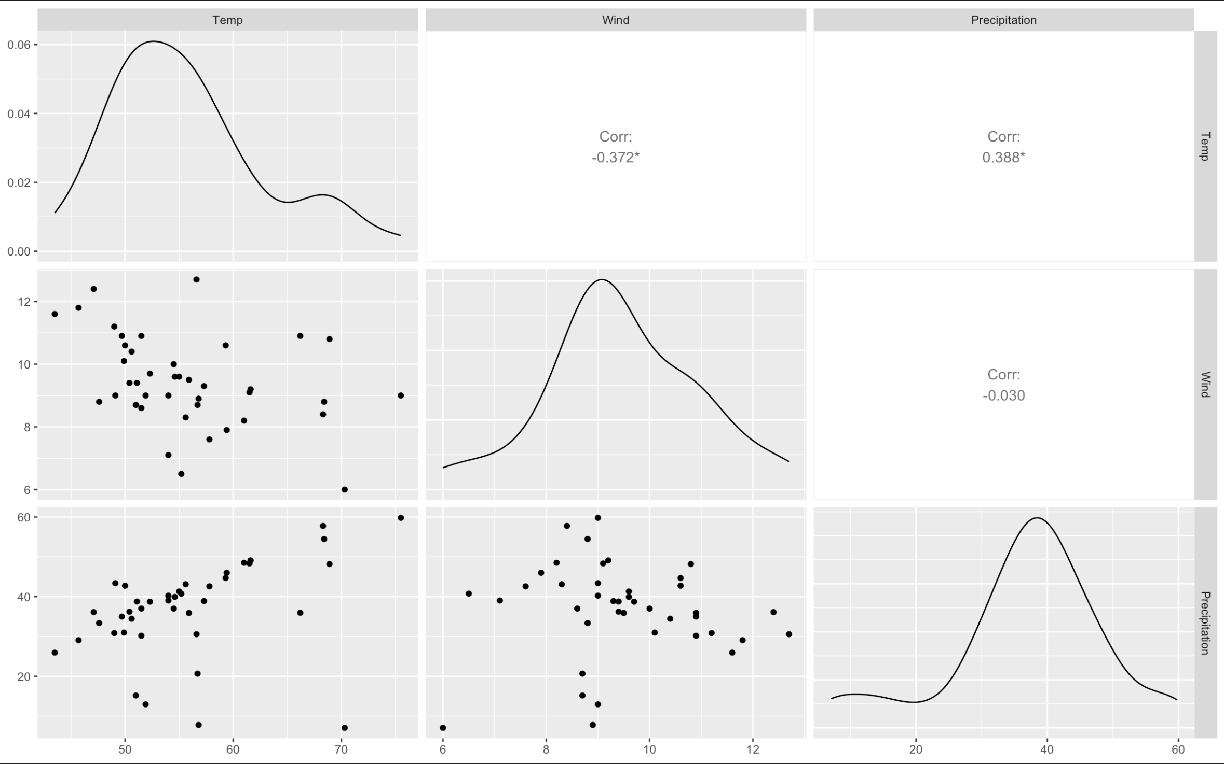
There is a significant negative correlation between wind and temp at -0.372, and a significant positive correlation for precipitation and temp at 0.388. There is also an insignificant negative correlation between wind and precipitation.
- Use the SalmonData on D2L. The data recorded the number of Salmon estimated for Chinook Salmon and steelhead (where possible) passing upstream of Princeton, CA in the upper Sacramento River Basin during the three seasons: Winter, Spring and Fall, in different years. There are three dependent variables: winter, spring and fall counts. Use PCA analysis to reduce the three variables down to one variable representing the three seasonal counts, and answer the following questions:
- What is the proportion of variation explained by the first PC?
77% of the variation is explained by the first PC
- How many PCs to keep? Why?
1 PC should be kept because it explains 77% of the variation, and it also is the only one with an eigen value above 1.
- What is the linear combination (Principal component 1)?
$$PC1= 0.53x_{1}+0.58x_{2}+0.62x_{3}$$
$x_{1}=Winter$, $x_{2}=Spring$, $x_{3}=Fall$
- Based on the biplot, what variables have strong correlations?
Spring and Fall have strong correlations.
3. Use the iris data in R to do a principal component analysis.
  - What are the eigenvalues?
PC1 2.91849782
PC2 0.91403047
PC3 0.14675688
PC4 0.02071484
  - What is the proportion of variation explained by the first principal component?
PC1 0.729620
PC2 0.2285100
PC3 0.0366900
PC4 0.0051800
  - How many principal components should you choose? Why?
1 PC should be kept because it explains 72.9% of the variation, and it also is the only one with an eigen value above 1.
  - Which two variables have higher weights on the first principal component?

  - What is the linear combination that you decided to use?

  - Based on the biplot, explain what you saw about correlations between variables?

